Project Development Phase
Performance Test

Date | 19 Febraury 2026
Team ID | LTVIP2026TMIDS41894
roject Name | Plugging into the Future: An Exploration of Electricity Consumption Patterns Using Tableau
Maximum Marks

Model Performance Testing:
Project team shall fill the following information in model performance testing template.
S.No. | Parameter | Screenshot / Values
 | Data Rendered | 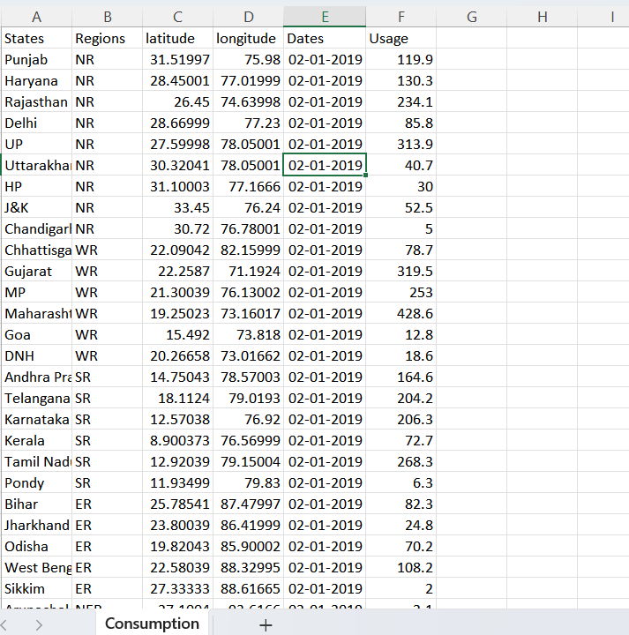
 | Data Preprocessing | 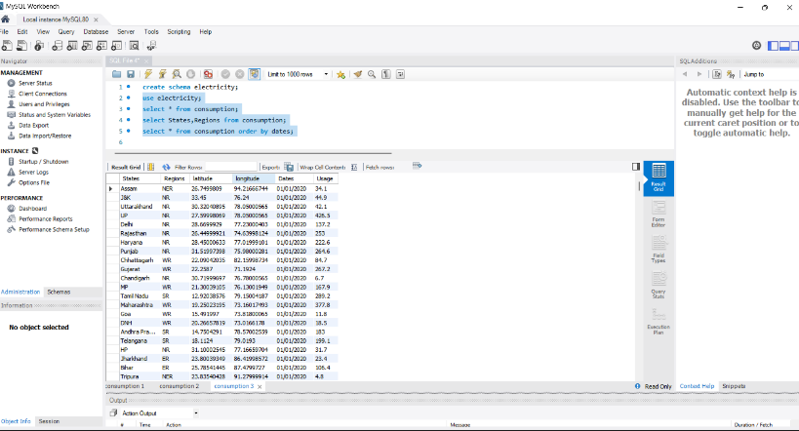
3. | Utilization of Filters | 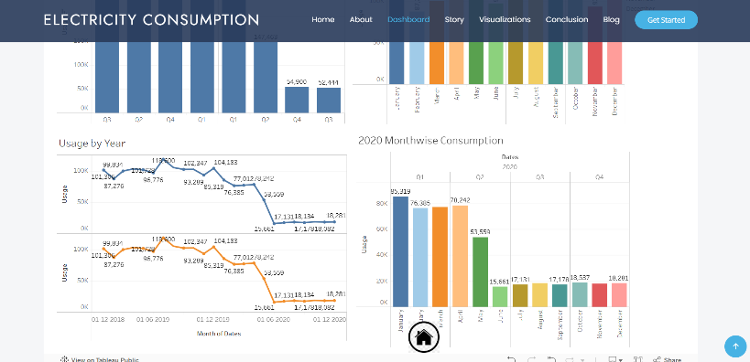
4. | Calculation fields Used | 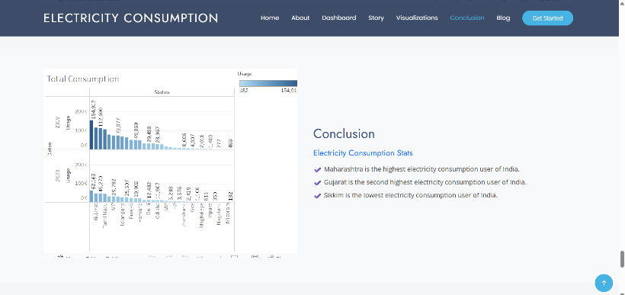
5. | Dashboard design | 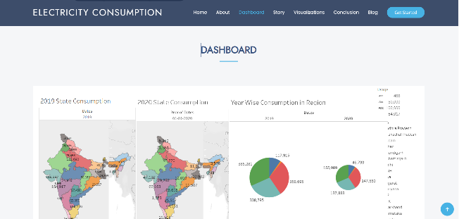
6 | Story Design | 